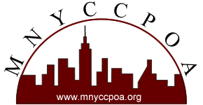

Application for the Alva C. Cooper Awards
for Best Practices In Career Development
If you have any questions, you can e-mail Laurie Joseph, laurie.joseph@ncc.edu, or call her at 516-572-7132.
First Name

Last Name

Title

Names and titles of additional applicant (s)

Name of Institution

Name of Department

Mailing Address – Street

City

State

Zip

Telephone Number

E-mail address

Submission Title

Are you a current member of MNYCCPOA? (Please note that membership in MNYCCPOA is a requirement for applying.)

Description of Best Practice

What need/problem was addressed by this work?

Why was this a significant achievement?

How does this program foster the professional growth of the MNYCCPOA member?

How does the program foster the growth of the students/alumni at your institution?

Did the program meet its objectives?

What were the results/outcomes of this work? Please provide quantitative or qualitative information when available/appropriate.

Additional Information (optional)

Are you are mailing supporting materials?

If yes, please email supporting materials to Laurie Joseph laurie.joseph@ncc.edu

E-MAIL THIS COMPLETED APPLICATION TO THE ALVA C. COOPER AWARDS COMMITTEE CHAIR LAURIE JOSEPH, laurie.joseph@ncc.edu.edu
The deadline is January 17, 2014.
If you do not receive a confirmation email in a few days, please contact Laurie at (516) 572-7132.

